**Technical Research Deeply**

**Break 3 models thành 3 bài : Prompting - Prompting - Recommender System.**

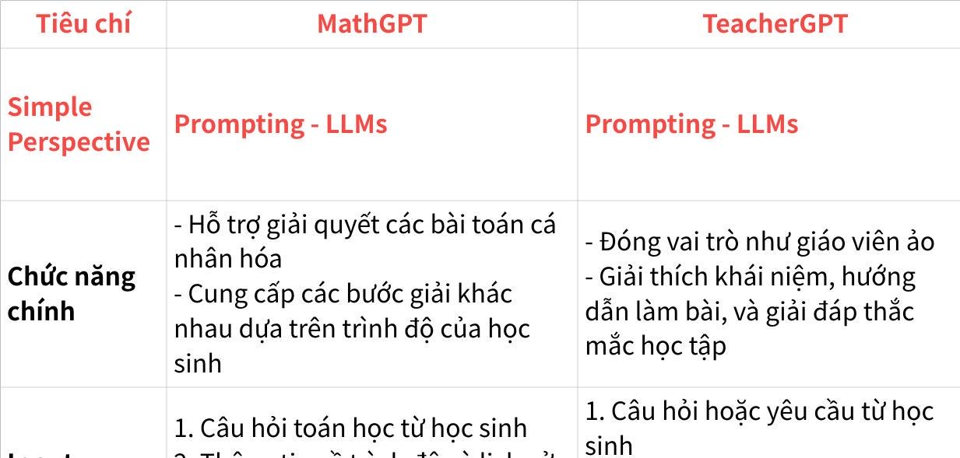

**Click the image to view the sheet.**

**Research Scales:**

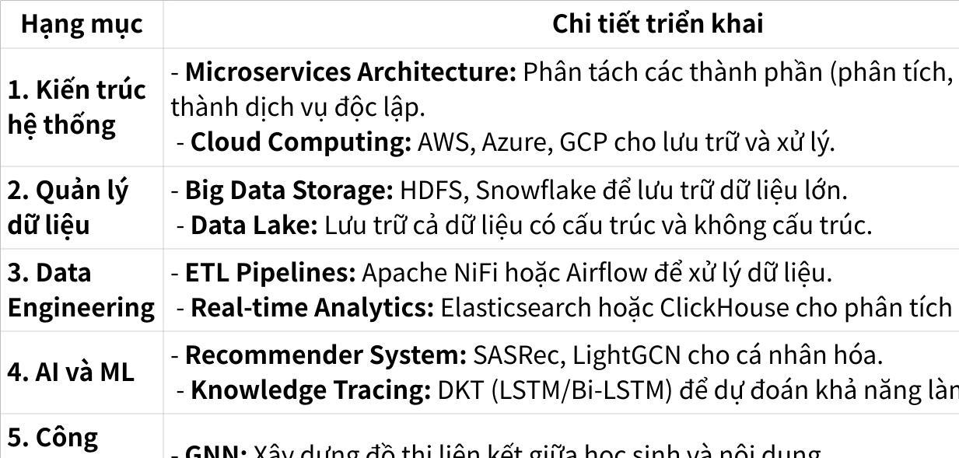

**Click the image to view the sheet.**

**Comments**